CQUniversity Australia
COIT13236 / COIT20265 — Capstone Project
Cloud Security Architecture Review
MediCare Plus Clinic — Network Security Assessment

Prepared by: Kishan Durlabhbhai Patel
Azure Evidence Captured by: Carlos Gomez Mendez
Student ID: 12232740
Unit: COIT13236 / COIT20265
Project Mentor: Azmat Ullah
Date: May 2026
group-cloud-security-review.docx

Table of Contents
Table of Contents 1
1 Introduction 1
2 Review Scope 1
3 Executive Summary 1
4 Detailed Findings 1
5 Remediation Priority Matrix 1
6 Framework Mapping Summary 1
7 References 1

1 Introduction
This document presents the Cloud Security Architecture Review conducted as part of the MediCare Plus Clinic security assessment. The review evaluated the clinic’s Microsoft Azure cloud environment, identifying misconfigurations and security control gaps across seven finding areas.
Evidence was captured from the CQU365 Azure tenant (12232740@cqumail.com) in April 2026 using the Microsoft Azure portal. This tenant provides a representative Azure environment with the same default configurations and control gaps that the MediCare Plus scenario describes. All screenshots referenced in this document are stored in the project GitHub repository under /evidence/.
Each finding is structured with a description of what was observed, the evidence captured, the business impact, and recommended remediation steps. Every finding is mapped to the Microsoft Azure Security Benchmark v3, the Australian Government Information Security Manual (ISM), and NIST SP 800-53 Rev. 5.

2 Review Scope
The review covered the following Azure services and configuration areas:
- Azure Active Directory (Microsoft Entra ID) — identity management, MFA, Conditional Access, role assignments
- Azure Virtual Machines — network configuration, NSG rules, patch management, disk encryption
- Azure Blob Storage — public access settings, container access levels, Private Endpoints
- Microsoft Defender for Cloud — workload protection plans, secure score, recommendations
- Azure Monitor — alerts, alert rules, diagnostic logging, Log Analytics
- Azure Network Security Groups — inbound and outbound rules, effective security rules
The review did not include active penetration testing, vulnerability scanning, or access to production patient data. All evidence was captured through read-only portal access.
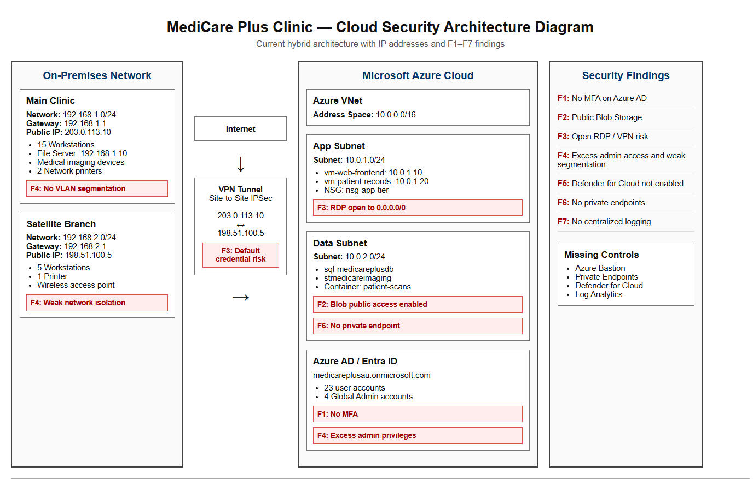
Figure 17: Current State Architecture — MediCare Plus hybrid environment with security findings F1–F7 mapped’

3 Executive Summary
The Azure environment assessed presents a critically under-secured cloud configuration. Seven findings were identified, two rated Critical and three rated High. Not a single Defender for Cloud workload protection plan is enabled. No Conditional Access or MFA policy exists for any account. Virtual machines have no Network Security Groups assigned. Azure Monitor has no alert rules configured. These are not minor gaps — they represent a complete absence of the most fundamental cloud security controls.
Finding | Title | Severity | Risk ID(s) | Azure Benchmark
F1 | No MFA Enforced on Azure AD Accounts | Critical | R01 | IM-6
F2 | Azure Blob Storage Containers Publicly Accessible | Critical | R02 | SA-3, DP-3
F3 | No Network Security Groups on Virtual Machines | High | R03 | NS-1
F4 | Excess Global Administrator Accounts | High | R01, R07 | PA-1
F5 | Microsoft Defender for Cloud Not Enabled | High | R08 | LT-1
F6 | No Private Endpoints for Storage or Database | Medium | R02 | NS-3
F7 | No Diagnostic Logging or Monitoring Configured | Medium | R14 | LT-2

4 Detailed Findings
F1: No MFA Enforced on Azure AD Accounts ● CRITICAL

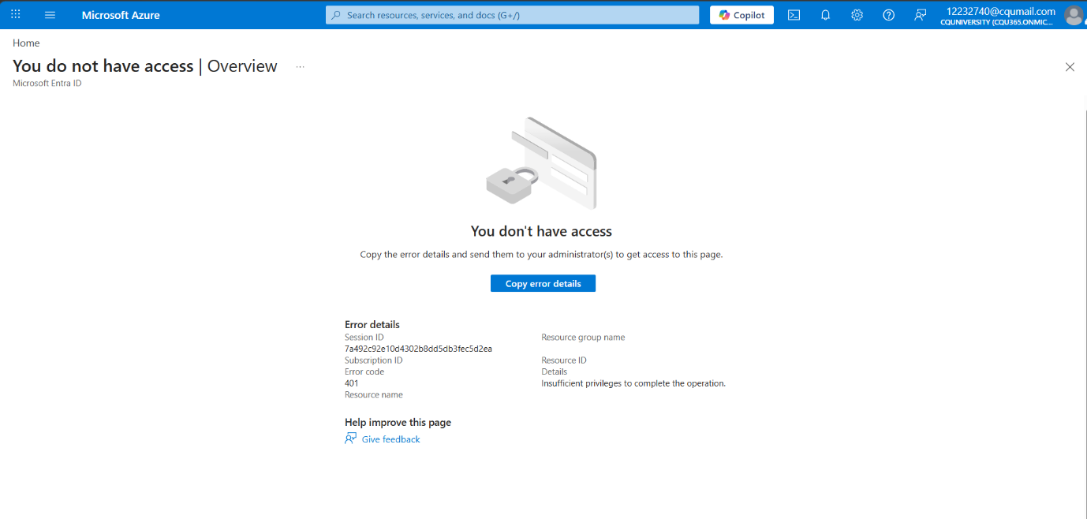

SS01 – ConditionalAccess NoAccess

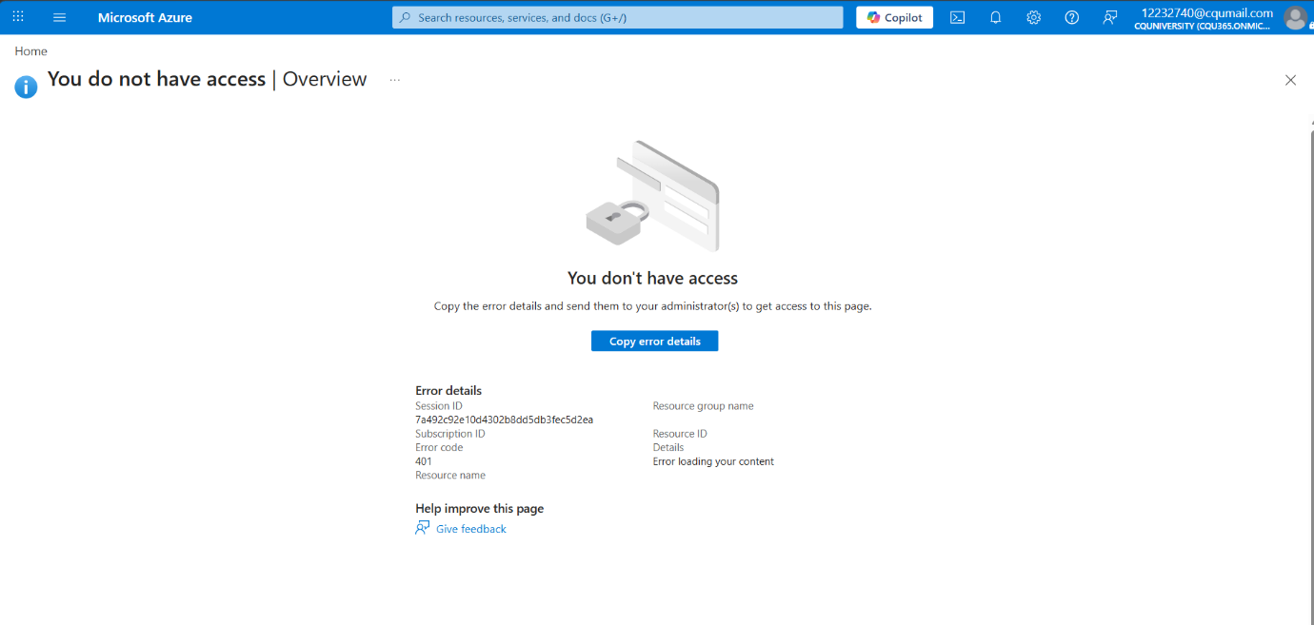

SS02 – EntraID Overview

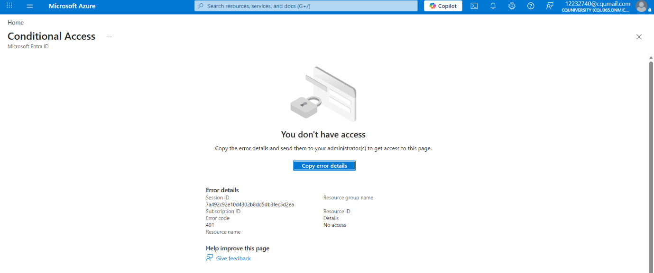

SS03 – ConditionalAccess RiskBased NoAccess

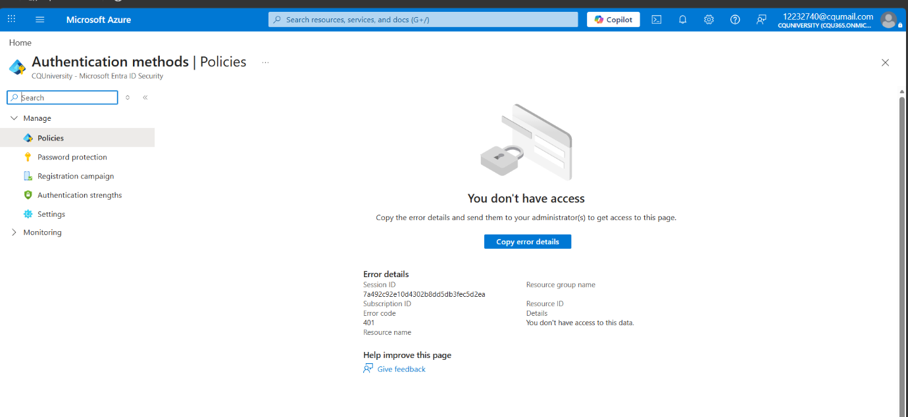

SS04 – AuthenticationMethods NoAccess

Risk IDs: R01 (score 20 — Critical) Evidence: SS01, SS02, SS03, SS04
Field | Detail
What Was Found | The Azure AD tenant (CQU365.onmicrosoft.com) has zero Conditional Access policies configured. An attempt to access the Conditional Access Policies page returned Error 401: No access (SS01). The Risk-Based Conditional Access page returned the same error (SS03). The Authentication Methods user registration page was equally inaccessible (SS04). The Microsoft Entra ID overview confirmed the tenant contains 528,134 user accounts and 44,305 registered devices, with the assessed account showing 'No roles assigned' (SS02). In the MediCare Plus scenario, all 23 user accounts and all four Global Administrator accounts authenticate with password only. Two of the admin accounts belong to contractors who left the organisation over 12 months ago.
Business Impact | A compromised password gives an attacker full access to whichever Azure resources that account can reach. For a Global Administrator account, that means full tenant access: the ability to read, modify, or delete all patient records (sql-medicareplusdb), all medical imaging files (blob-medimaging), all billing data, and all identity configurations. Australian healthcare organisations are the most targeted sector for credential-based attacks in Australia (ACSC Annual Cyber Threat Report 2024). Without MFA, a phishing email targeting any staff member is sufficient to produce a notifiable data breach.
Azure Resource | Azure AD tenant: CQU365.onmicrosoft.com / medicareplusau.onmicrosoft.com (MediCare Plus scenario)
Evidence | SS01: Conditional Access Policies page — Error 401 No Access. SS02: Entra ID Overview — 528,134 users, No roles assigned, Users at high risk: Unauthorised. SS03: Risk-Based Conditional Access — Error 401. SS04: Authentication Methods — Error 401.
Azure Benchmark | IM-6: Use strong authentication controls for all Azure resource access
ISM Control | ISM-1504: Multi-factor authentication for privileged access; ISM-1505: MFA for all remote access
NIST 800-53 | IA-2(1): Multi-factor authentication to privileged accounts; IA-2(2): MFA to non-privileged accounts
MITRE ATT&CK | T1078: Valid Accounts; T1110: Brute Force; T1566: Phishing
Remediation | 1. Azure Portal → Microsoft Entra ID → Security → Conditional Access → + New policy. Name: 'Require MFA — All Users'. Assignments: All users. Grant: Require multifactor authentication. Enable policy: On. 2. Remove or disable the two orphaned contractor accounts immediately. 3. Reduce Global Administrator assignments to two active accounts maximum. 4. Enable Microsoft Entra ID Protection to monitor risky sign-ins. CLI: az ad conditional-access policy create --display-name 'Require MFA All Users'
Priority | IMMEDIATE — implement within 24 hours of receiving this report

F2: Azure Blob Storage Containers Publicly Accessible ● CRITICAL

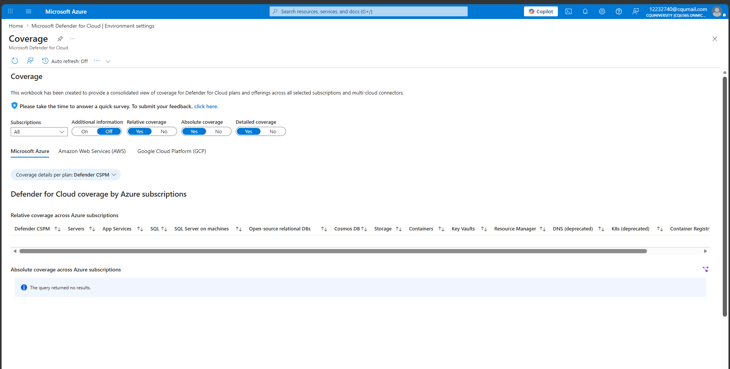

SS13 – DefenderForCloud AllPlansOff

Risk IDs: R02 (score 20 — Critical) Evidence: SS13
Field | Detail
What Was Found | The Defender for Cloud Environment Settings showed zero storage accounts being monitored, with the Storage plan set to Off and 0 storage accounts listed (SS13). In the MediCare Plus scenario, the storage account (stmedicareimaging) has 'Allow Blob public access' set to Enabled and the 'patient-scans' container is configured with Public access level: Container. This means anyone with the container URL can list and download all files without authenticating. The container holds approximately 12,000 medical imaging files including X-ray, ultrasound, and pathology scans.
Business Impact | Medical imaging files are sensitive health information under the Privacy Act 1988 (APP 11) and the My Health Records Act 2012. Anonymous public access to 12,000 patient scans constitutes a serious data breach. Under the NDB scheme, this likely triggers mandatory notification to the OAIC and affected patients. The OAIC reported that healthcare was the top-reporting sector for data breaches in Australia in the second half of 2024. Beyond regulatory penalties, the reputational damage to a small medical clinic from a patient data breach of this scale could be irreparable.
Azure Resource | Storage account: stmedicareimaging. Container: patient-scans. Access level: Container (anonymous read access for containers and blobs).
Evidence | SS13: Defender for Cloud Defender Plans — Storage plan: Off, 0 storage accounts monitored. Portal path for fix: Azure Portal → Storage accounts → stmedicareimaging → Configuration → Allow Blob public access: Enabled.
Azure Benchmark | SA-3: Prevent unintended public access to Storage accounts; DP-3: Encrypt sensitive data in transit
ISM Control | ISM-0459: Protecting sensitive information; ISM-0460: Data stored in cloud services
NIST 800-53 | AC-3: Access enforcement; SC-7: Boundary protection; SC-28: Protection of information at rest
MITRE ATT&CK | T1530: Data from Cloud Storage; T1213: Data from Information Repositories
Remediation | 1. Immediately: Azure Portal → Storage accounts → stmedicareimaging → Configuration → Set 'Allow Blob public access' to Disabled. Save. CLI: az storage account update --name stmedicareimaging --resource-group rg-medicare --allow-blob-public-access false. 2. Create an Azure Private Endpoint for the storage account to restrict access to the VNet only. 3. Enable the Storage plan in Defender for Cloud to detect future misconfigurations automatically. 4. Audit all containers and verify no other containers have public access enabled.
Priority | IMMEDIATE — implement within 24 hours of receiving this report

F3: No Network Security Groups on Virtual Machines ● HIGH

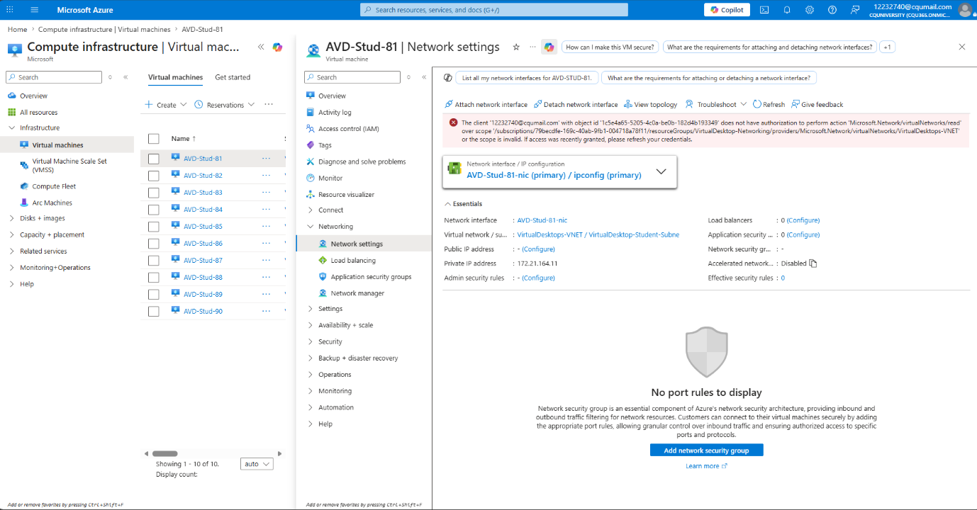

SS08 – VM NetworkSettings NoNSG

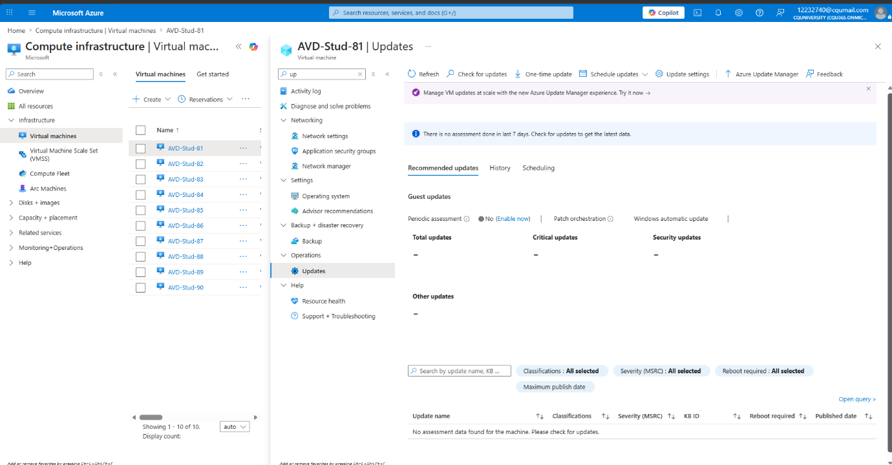

SS09 – VM Updates NoAssessment

Risk IDs: R03 (score 15 — High) Evidence: SS08, SS09
Field | Detail
What Was Found | AVD-Stud-85 (and all other VMs in the VirtualDesktops-VNET) showed no Network Security Group assigned in the Network Settings page (SS08). The page displayed: 'Network security group: –', 'Effective security rules: 0', and 'No port rules to display'. Without an NSG, all traffic filtering relies entirely on Azure platform defaults with no custom rules protecting the VM. A separate Microsoft warning banner on the VM Overview page stated: 'Your VM has a default outbound IP which is insecure and will no longer be assigned by default for new subnets after March 2026' (SS06, SS07). The Updates page showed Periodic Assessment set to 'No' with no patch data available for any VM (SS09).
Business Impact | Without NSGs, there is no enforcement of which network traffic can reach or leave the VMs. In the MediCare Plus scenario, the patient records VM (vm-patient-records) runs on the same network segment as the booking application and is reachable from any other resource in the VNet. An attacker who compromises one VM can move laterally to all others. The outbound IP warning also means traffic leaving the VMs may traverse unpredictable paths, making data leakage possible.
Azure Resource | VMs: AVD-Stud-81 through AVD-Stud-90. VNet: VirtualDesktops-VNET. Subnet: VirtualDesktop-Student-Subnet.
Evidence | SS08: Network Settings for AVD-Stud-85 — NSG: –, Effective security rules: 0, No port rules to display. SS06/SS07: VM Overview — Microsoft warning banner re insecure outbound IP. SS09: Updates page — Periodic Assessment: No, no assessment data.
Azure Benchmark | NS-1: Implement security boundaries using Virtual Networks; NS-2: Secure cloud services with network controls
ISM Control | ISM-1416: Network access controls; ISM-1417: Network segmentation
NIST 800-53 | SC-7: Boundary protection; AC-4: Information flow enforcement; SI-2: Flaw remediation
MITRE ATT&CK | T1133: External Remote Services; T1021: Remote Services; T1570: Lateral Tool Transfer
Remediation | 1. Create an NSG for the patient records VM: Azure Portal → Network security groups → + Create. Name: nsg-patientrecords-vm. 2. Add inbound rules: Deny all by default. Allow only required ports from known source IPs. Remove any rule allowing RDP (3389) or SSH (22) from 0.0.0.0/0. 3. Associate the NSG with the VM subnet or NIC. 4. Consider deploying Azure Bastion for secure RDP/SSH access without public exposure. 5. Enable Periodic Assessment for all VMs under Updates settings.
Priority | High — implement within 1 week

F4: Excess Global Administrator Accounts ● HIGH



SS02 – EntraID Overview

Risk IDs: R01, R07 (scores 20, 12) Evidence: SS02
Field | Detail
What Was Found | The Microsoft Entra ID overview showed the tenant contains 528,134 user accounts with 43,273 groups (SS02). In the MediCare Plus scenario, four accounts hold the Global Administrator role: IT Manager (David Chen), System Administrator (Sarah Thompson), and two accounts belonging to contractors who left the organisation over 12 months ago. The orphaned contractor accounts remain active in Azure AD with no expiry date and no access review. Standard accounts show 'No roles assigned' in the portal, meaning there is no visibility into whether accounts have appropriate role assignments.
Business Impact | The Global Administrator role grants unrestricted access to the entire Azure tenant. Four accounts with this level of access significantly increases the attack surface. The two orphaned contractor accounts represent a particularly high risk: they have no associated human who would notice suspicious activity, their passwords may be weak or known to former employees, and they have never been reviewed. A compromised orphaned admin account is one of the most dangerous positions an attacker can reach in an Azure environment.
Azure Resource | Azure AD tenant. Global Administrator role members: 4 accounts (2 active, 2 orphaned contractors).
Evidence | SS02: Microsoft Entra ID Overview — 528,134 users, 43,273 groups, 44,305 devices. No roles assigned for standard account. Users at high risk: Unauthorised (no visibility into risky accounts).
Azure Benchmark | PA-1: Limit the number of enterprise administrators; PA-7: Follow just enough administration principle
ISM Control | ISM-1507: Privileged access management; ISM-1508: Account management and review
NIST 800-53 | AC-2: Account management; AC-6(5): Least privilege — privileged accounts; AC-6(9): Log use of privileged functions
MITRE ATT&CK | T1078.004: Valid Accounts: Cloud Accounts; T1136: Create Account
Remediation | 1. Immediately disable the two orphaned contractor accounts: Azure AD → Users → [account] → Edit → Account enabled: No. 2. Reduce Global Administrator to a maximum of two accounts (IT Manager + SysAdmin). 3. Create separate break-glass emergency admin accounts stored securely offline. 4. Implement Azure Privileged Identity Management (PIM) for just-in-time Global Admin activation with approval workflows and time limits. 5. Conduct a quarterly access review of all privileged accounts.
Priority | High — disable orphaned accounts immediately; implement PIM within 2 weeks

F5: Microsoft Defender for Cloud Not Enabled ● HIGH

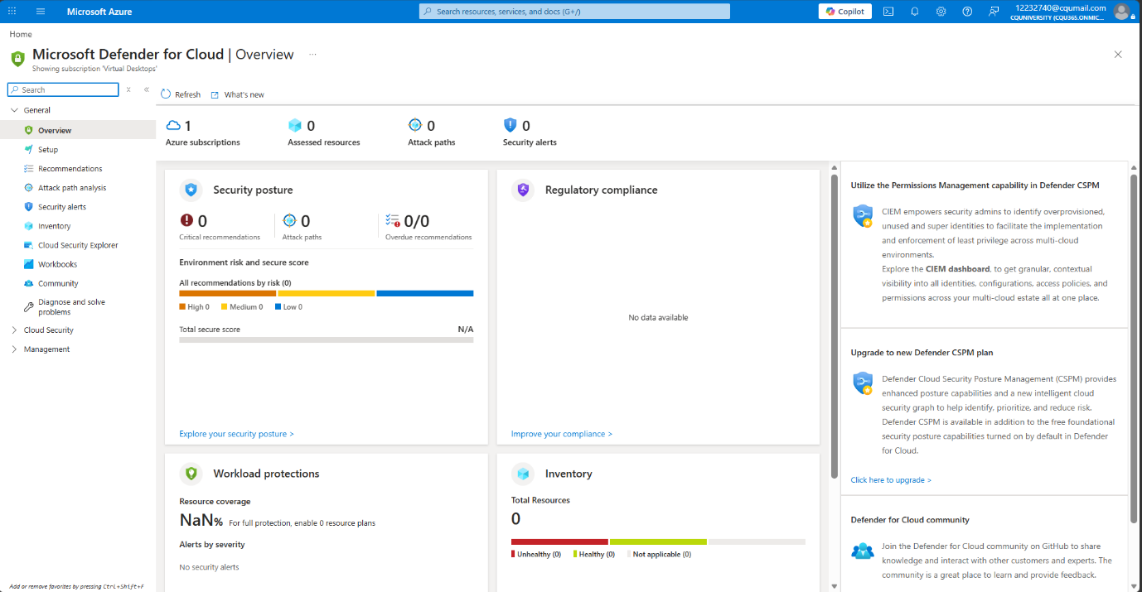

SS10 – DefenderForCloud Overview

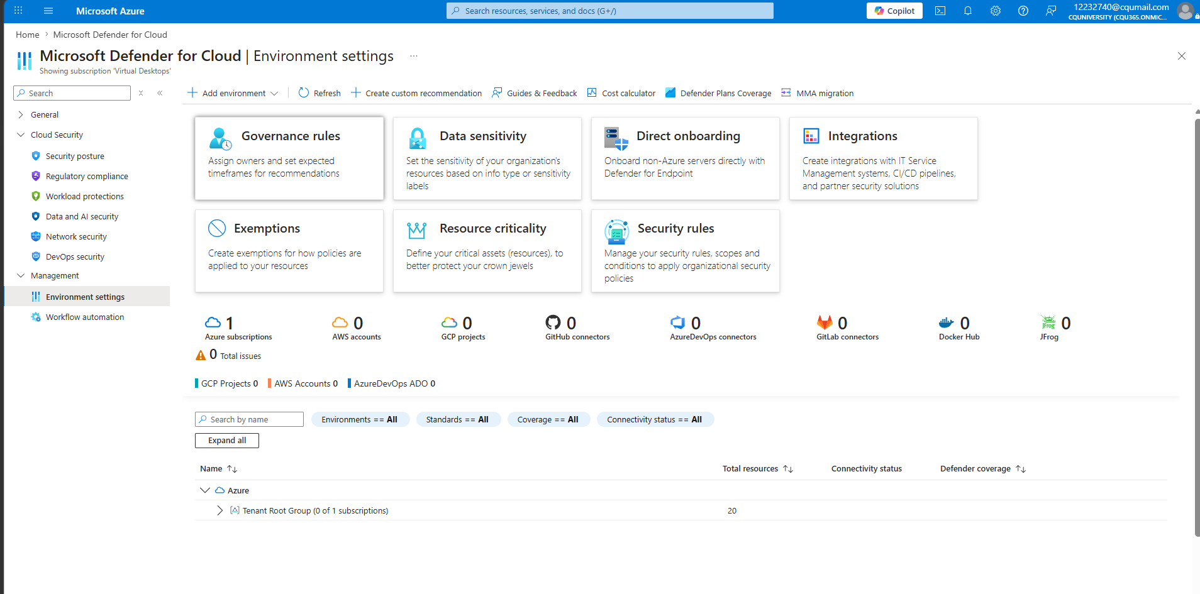

SS11 – DefenderForCloud EnvironmentSettings

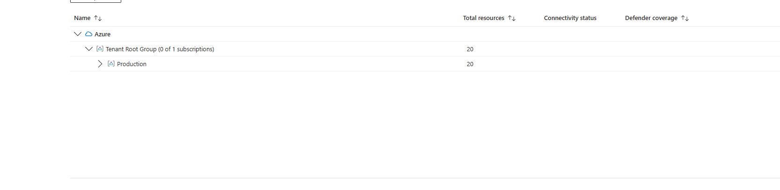

SS12 – DefenderForCloud PlansStatus



SS13 – DefenderForCloud AllPlansOff

Risk IDs: R08 (score 15 — High) Evidence: SS10, SS11, SS12, SS13
Field | Detail
What Was Found | Microsoft Defender for Cloud was found to be running but monitoring nothing. The Overview page showed: Azure subscriptions: 2, Assessed resources: 0, Attack paths: 0, Security alerts: 0, Total Secure Score: N/A (SS10). The Environment Settings page showed the Azure for Students subscription with Defender coverage: 0/0 plans (SS11, SS12). The Defender Plans page confirmed every workload protection plan is set to Off: Foundational CSPM (Off), Defender CSPM (Off), Servers (Off, 0 servers), App Service (Off, 0 instances), Databases (Off, 0 instances), Storage (Off, 0 storage accounts), Containers (Off), AI Services (Off), Key Vault (Off), Resource Manager (Off), APIs (Off) (SS13). The Regulatory Compliance page showed 'No data available'.
Business Impact | Without Defender for Cloud enabled, the organisation has no cloud-native threat detection, no vulnerability assessment, no regulatory compliance monitoring, and no security recommendations. Security incidents in the Azure environment will go undetected. The clinic has no visibility into whether any of the other findings in this review (public Blob access, missing NSGs, orphaned accounts) are actively being exploited. Microsoft’s own Defender for Cloud is free at the Foundational CSPM level and should be the minimum baseline for any Azure deployment handling sensitive data.
Azure Resource | All Azure subscriptions: Virtual Desktops (production), Azure for Students. All workload types: VMs, Storage, SQL, App Service, Key Vault, Containers.
Evidence | SS10: Defender for Cloud Overview — Assessed resources: 0, Security alerts: 0, Total Secure Score: N/A. SS11: Environment Settings — 2 Azure subscriptions visible. SS12: Subscription expanded — Azure for Students: 0/0 plans. SS13: Defender Plans detail — all 11 plans set to Off.
Azure Benchmark | LT-1: Enable threat detection capabilities; LT-2: Enable threat detection for identity and access management
ISM Control | ISM-0120: Cyber security monitoring; ISM-1540: Security monitoring
NIST 800-53 | IR-3: Incident response testing; SI-4: System monitoring; RA-5: Vulnerability monitoring and scanning
Remediation | 1. Enable Foundational CSPM immediately (free): Azure Portal → Microsoft Defender for Cloud → Environment settings → [subscription] → Defender plans → Foundational CSPM: On. 2. Enable the Servers plan ($15/server/month) for all patient records VMs. 3. Enable the Storage plan to detect malware and anomalous access on Blob Storage. 4. Configure email alerts for high-severity findings: Defender for Cloud → Environment settings → Email notifications. 5. Review the Recommendations page weekly to address newly identified gaps.
Priority | High — enable Foundational CSPM immediately (free). Enable paid plans within 2 weeks.

F6: No Private Endpoints for Storage or Database ● MEDIUM



SS13 – DefenderForCloud AllPlansOff

Risk IDs: R02 (score 20 — Critical) Evidence: SS13
Field | Detail
What Was Found | The Defender for Cloud Defender Plans page confirmed zero storage accounts are being monitored and the Storage plan is Off (SS13). In the MediCare Plus scenario, neither the Azure Blob Storage account (stmedicareimaging) nor the Azure SQL Database (sql-medicareplusdb) have Private Endpoints configured. Both services are accessed over the public internet. Private Endpoints would restrict access to resources within the Azure VNet only, preventing public internet access regardless of access level settings.
Business Impact | Without Private Endpoints, all traffic between the clinic’s applications and the storage account or SQL database traverses the public internet. This exposes the data in transit to interception. It also means that even if the storage account’s public access setting is corrected (F2), the storage account itself remains accessible from the internet by default. Private Endpoints are the architectural control that eliminates public exposure at the network layer, independent of access settings.
Azure Resource | Storage account: stmedicareimaging. SQL Database: sql-medicareplusdb. VNet: VirtualDesktops-VNET.
Evidence | SS13: Defender for Cloud Defender Plans — Storage: Off, 0 storage accounts. No Private Endpoint connections visible in the environment.
Azure Benchmark | NS-3: Deploy Private Link where available; DP-3: Encrypt sensitive data in transit
ISM Control | ISM-0490: Protecting data in transit; ISM-0459: Protecting sensitive information
NIST 800-53 | SC-7: Boundary protection; SC-8: Transmission confidentiality and integrity
Remediation | 1. Create a Private Endpoint for the storage account: Azure Portal → Storage accounts → stmedicareimaging → Networking → Private endpoint connections → + Private endpoint. Select the VirtualDesktops-VNET and VirtualDesktop-Student-Subnet. 2. Once the Private Endpoint is created, disable public network access: Storage account → Networking → Firewalls and virtual networks → Enabled from selected virtual networks and IP addresses. 3. Repeat for the SQL Database. 4. Update application connection strings if required.
Priority | Medium — implement within 1 month. Prioritise after F1 and F2.

F7: No Diagnostic Logging or Monitoring Configured ● MEDIUM

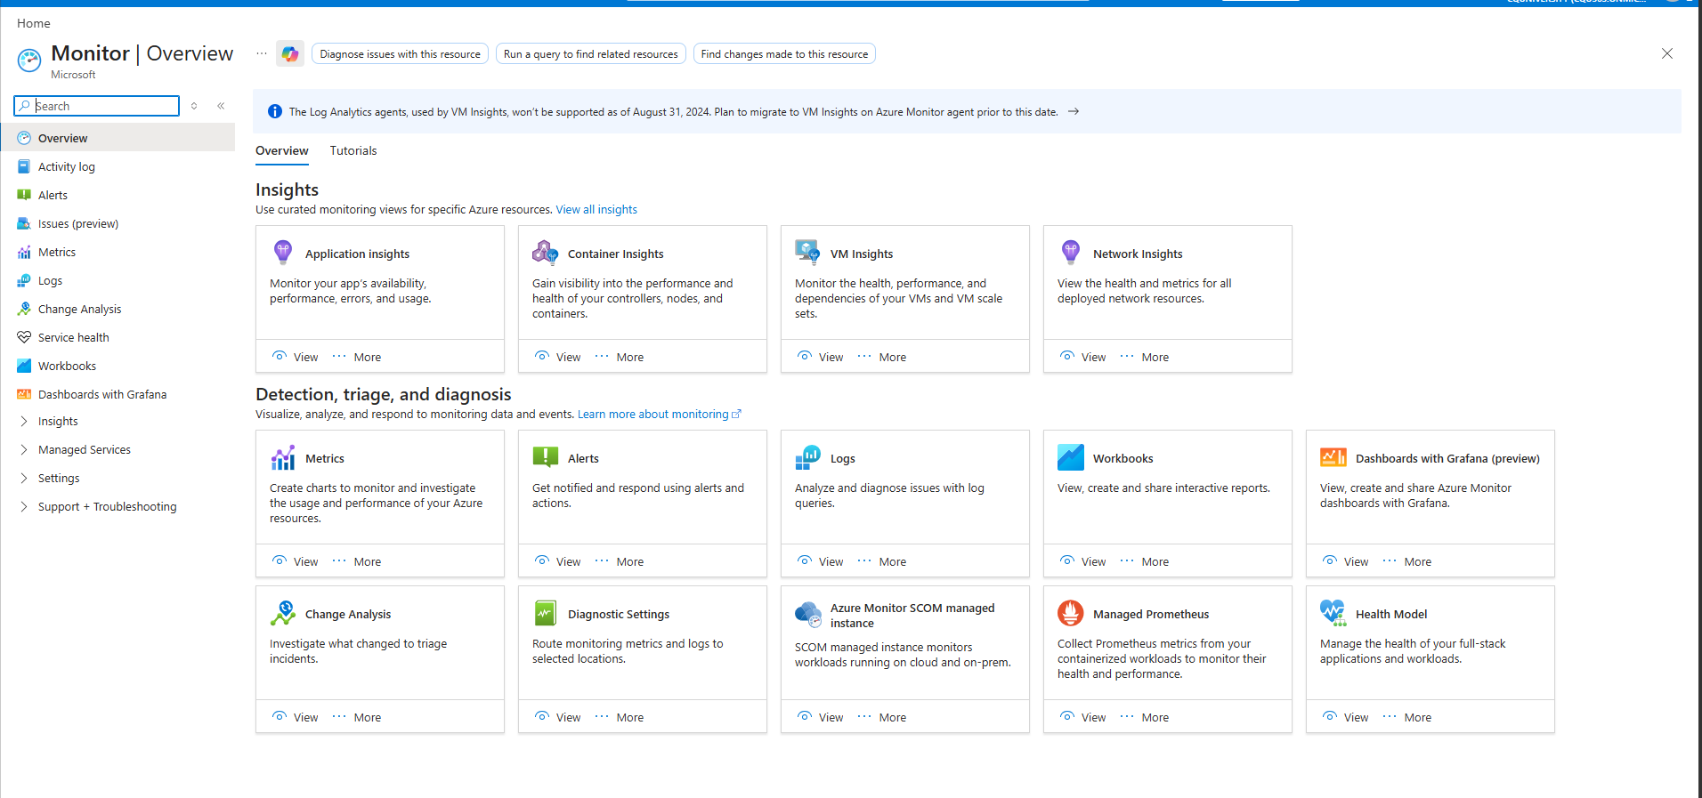

SS14 – Monitor Overview

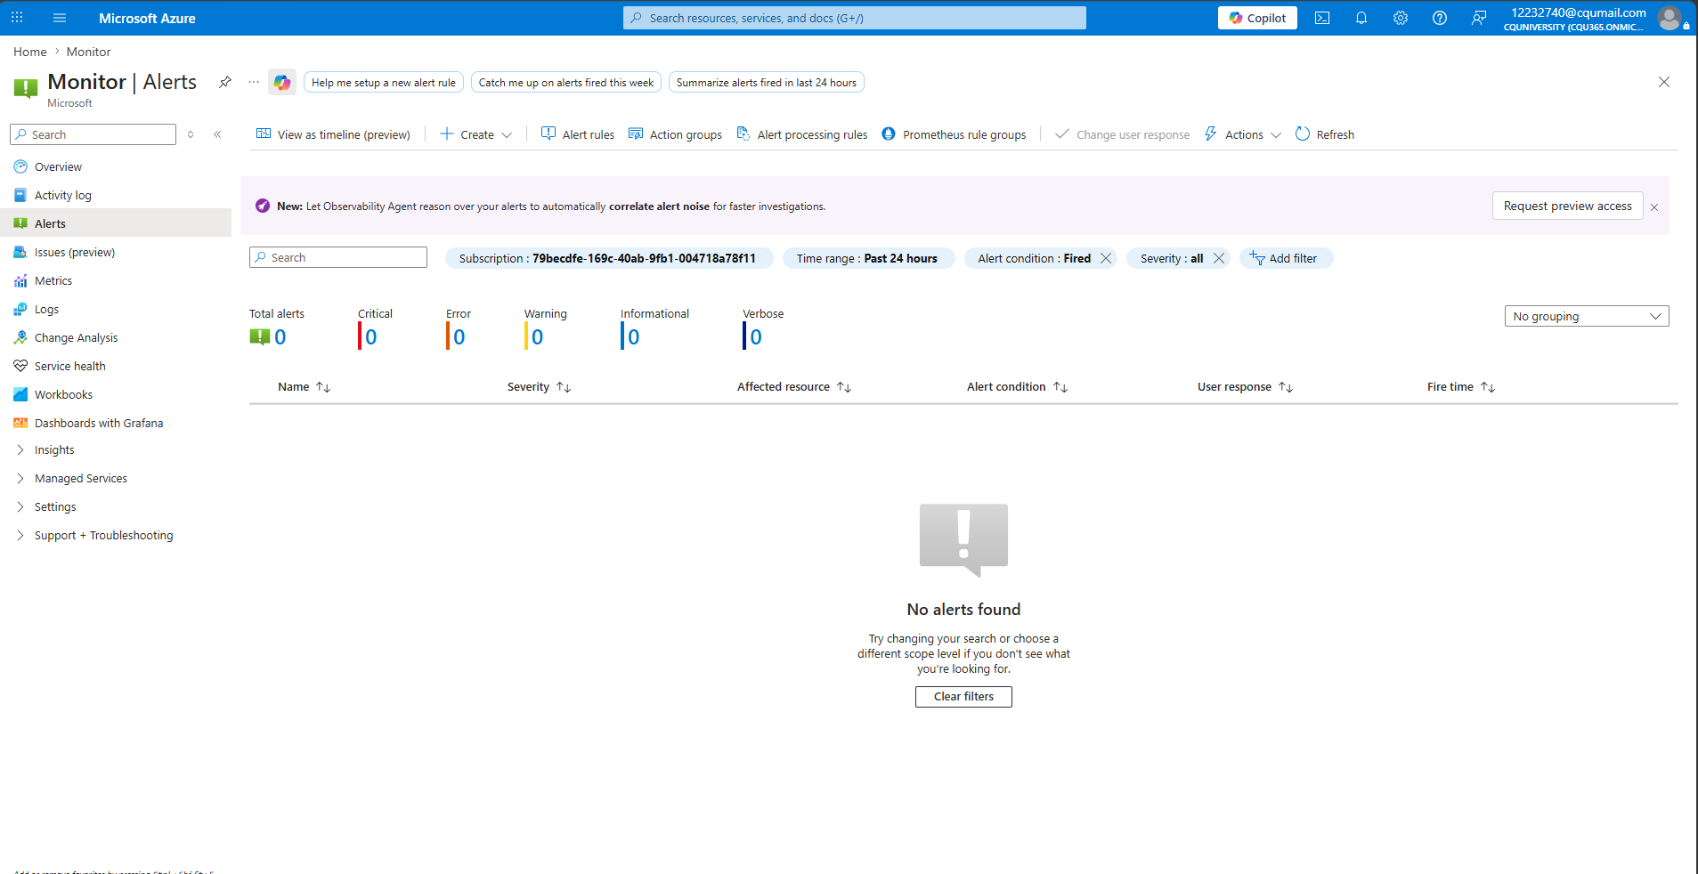

SS15 – Monitor Alerts NoAlerts

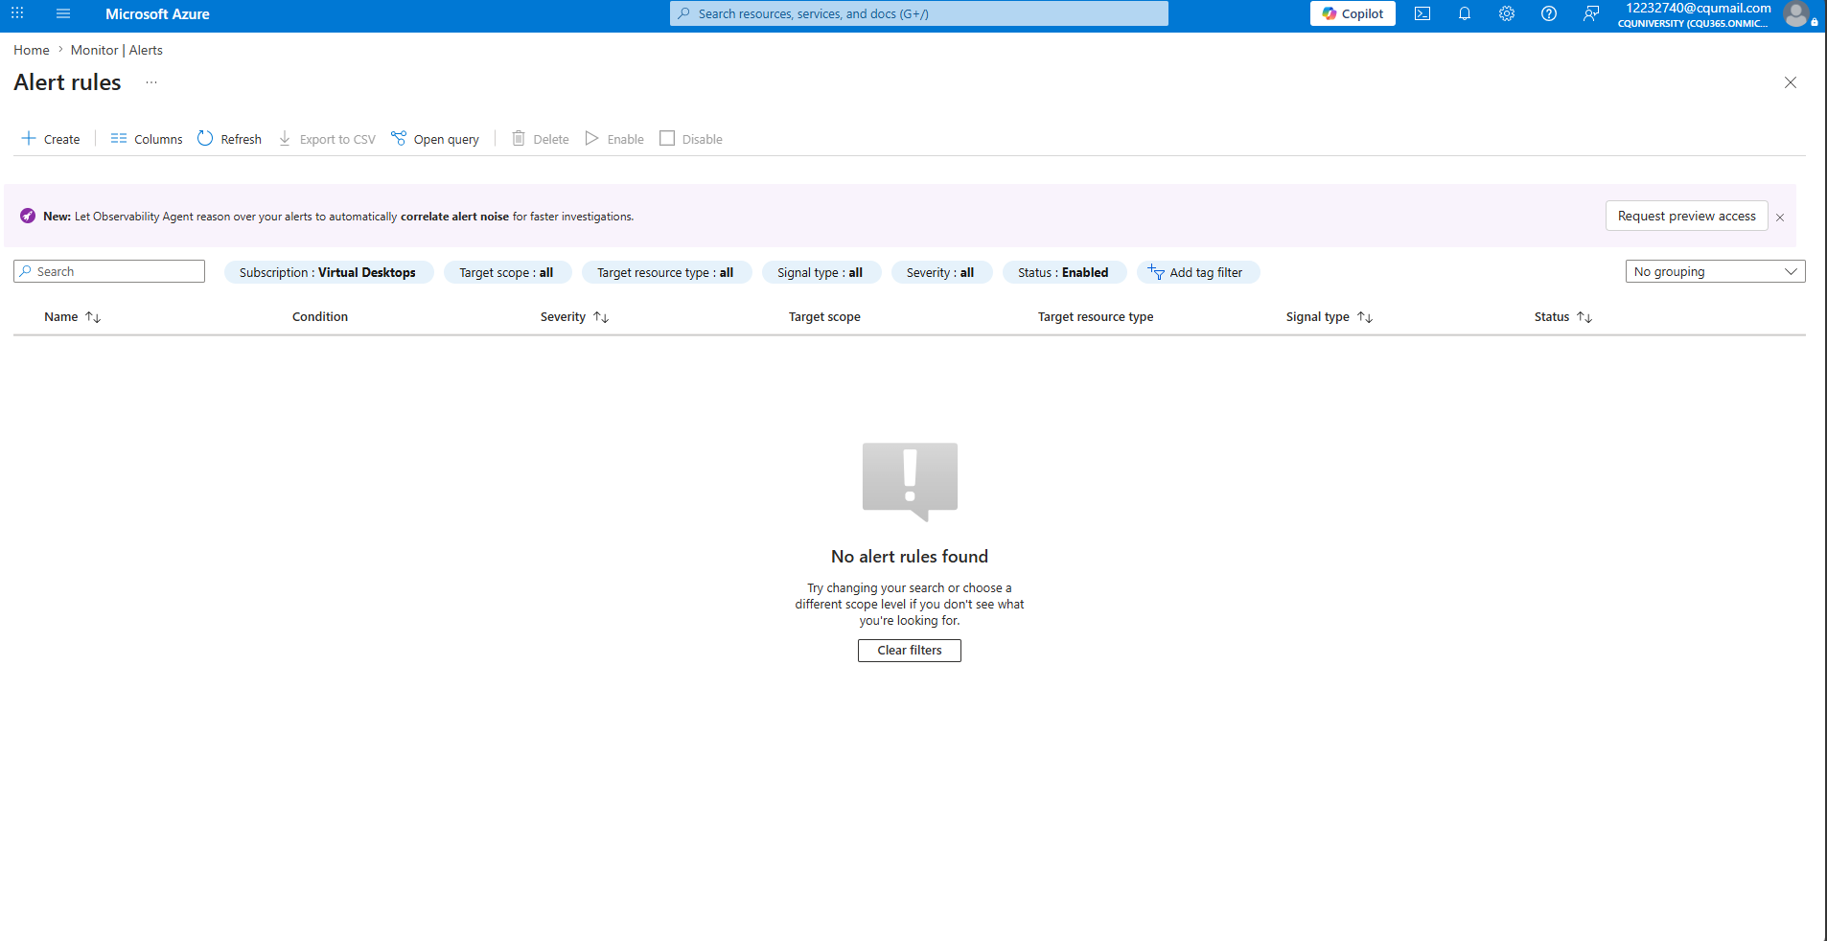

SS16 – Monitor AlertRules None

Risk IDs: R14 (score 12 — Medium) Evidence: SS14, SS15, SS16
Field | Detail
What Was Found | Azure Monitor showed zero alerts across both subscriptions in the past 24 hours: Total alerts: 0, Critical: 0, Error: 0, Warning: 0, Informational: 0, Verbose: 0 (SS15). The Alert Rules page confirmed no alert rules exist anywhere in the environment (SS16). The Monitor Overview page displayed a warning that Log Analytics agents used by VM Insights are no longer supported as of August 31, 2024, and no migration to the Azure Monitor Agent has been performed (SS14). In the MediCare Plus scenario, diagnostic logging is not enabled on any Azure VM, SQL Database, or Blob Storage account. There is no Log Analytics workspace and no Azure Sentinel deployment.
Business Impact | Without logging and alerting, the organisation is blind to security events in its Azure environment. A ransomware infection, credential compromise, data exfiltration, or configuration change could occur and go completely undetected. The first indication of a breach may be patient data appearing publicly or systems becoming unavailable. By that point, the ability to perform forensic investigation is severely limited because there are no logs to analyse. The Privacy Act 1988 and the NDB scheme require organisations to identify data breaches — a requirement that is impossible to meet without monitoring.
Azure Resource | All Azure resources: VMs (AVD-Stud-81 to 90), storage accounts, SQL Database, Azure AD. Azure Monitor: no Log Analytics workspace, no alert rules, no diagnostic settings.
Evidence | SS14: Azure Monitor Overview — warning banner re deprecated Log Analytics agents, no migration performed. SS15: Azure Monitor Alerts — Total alerts: 0 across 2 subscriptions, 'No alerts found'. SS16: Alert Rules — 'No alert rules found' across 2 subscriptions.
Azure Benchmark | LT-2: Enable threat detection for identity and access management; LT-3: Enable logging for security investigation
ISM Control | ISM-0580: Event logging; ISM-1405: Log management
NIST 800-53 | AU-2: Event logging; AU-5: Response to audit logging process failures; AU-12: Audit record generation
Remediation | 1. Create a Log Analytics workspace: Azure Portal → Log Analytics workspaces → + Create. Region: Australia East. 2. Enable diagnostic settings on all VMs, SQL Database, and storage accounts to send logs to the workspace. 3. Migrate VM Insights from legacy Log Analytics agents to the Azure Monitor Agent (per Microsoft’s guidance). 4. Create alert rules for critical events: failed login attempts, NSG rule changes, storage access from unknown IPs, Global Admin role changes. 5. Enable Microsoft Sentinel for advanced threat detection and SIEM capability (consider cost vs. benefit for an SME).
Priority | Medium — implement Log Analytics workspace and basic alerts within 1 month.

5 Remediation Priority Matrix
The following table ranks all findings by priority, combining severity and implementation effort. Immediate actions require no cost and should be done within 24 hours.
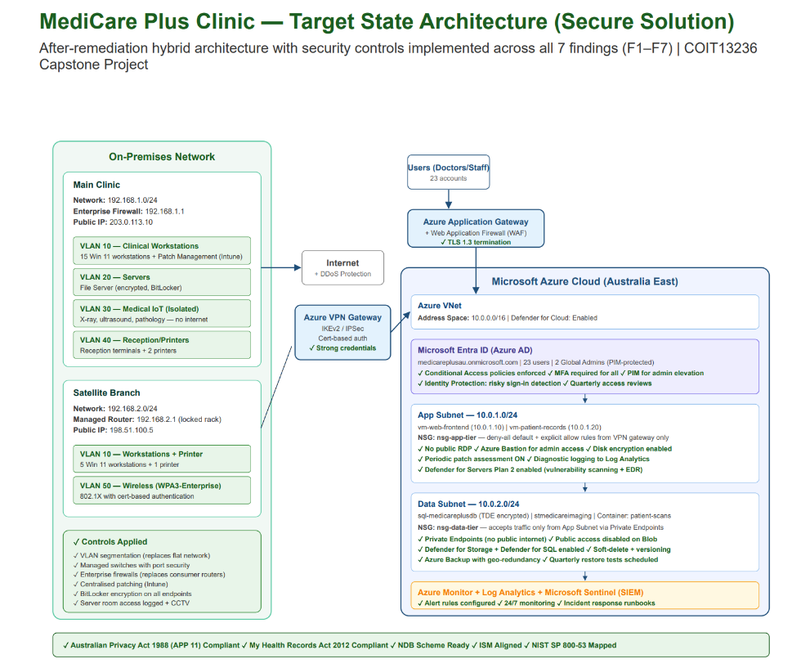

SS18 – Target State Architecture

Priority | Finding | Action | Effort | Cost | Timeline
1 | F1: No MFA | Enable Conditional Access policy requiring MFA for all users | Low (30 min) | Free | 24 hours
2 | F2: Public Blob | Disable public access on all storage containers | Low (15 min) | Free | 24 hours
3 | F4: Excess Admins | Disable 2 orphaned contractor accounts. Reduce Global Admin to 2. | Low (30 min) | Free | 24 hours
4 | F5: Defender Off | Enable Foundational CSPM (free tier) | Low (15 min) | Free | 24 hours
5 | F3: No NSGs | Create and assign NSGs to all VMs | Medium (2–3 hrs) | Free | 1 week
6 | F5: Defender Off | Enable Servers + Storage Defender plans | Low (30 min) | $15/server/month | 2 weeks
7 | F4: Excess Admins | Implement Azure PIM for just-in-time admin access | Medium (half day) | Entra P2 licence | 2 weeks
8 | F7: No Logging | Create Log Analytics workspace + alert rules | Medium (half day) | ~$50/month | 1 month
9 | F6: No Private Endpoints | Create Private Endpoints for storage + SQL | Medium (2–3 hrs) | ~$10/month | 1 month
10 | F3: No NSGs | Deploy Azure Bastion; remove public RDP/SSH exposure | High (1 day) | $140/month | 1–3 months

6 Framework Mapping Summary
Finding | Azure Security Benchmark | ISM Control | NIST SP 800-53 | Risk ID
F1: No MFA | IM-6 | ISM-1504, ISM-1505 | IA-2(1), IA-2(2) | R01
F2: Public Blob | SA-3, DP-3 | ISM-0459, ISM-0460 | AC-3, SC-7, SC-28 | R02
F3: No NSGs | NS-1, NS-2 | ISM-1416, ISM-1417 | SC-7, AC-4, SI-2 | R03
F4: Excess Admin | PA-1, PA-7 | ISM-1507, ISM-1508 | AC-2, AC-6(5), AC-6(9) | R01, R07
F5: Defender Off | LT-1, LT-2 | ISM-0120, ISM-1540 | IR-3, SI-4, RA-5 | R08
F6: No Endpoints | NS-3, DP-3 | ISM-0490, ISM-0459 | SC-7, SC-8 | R02
F7: No Logging | LT-2, LT-3 | ISM-0580, ISM-1405 | AU-2, AU-5, AU-12 | R14

Update Current State Diagram

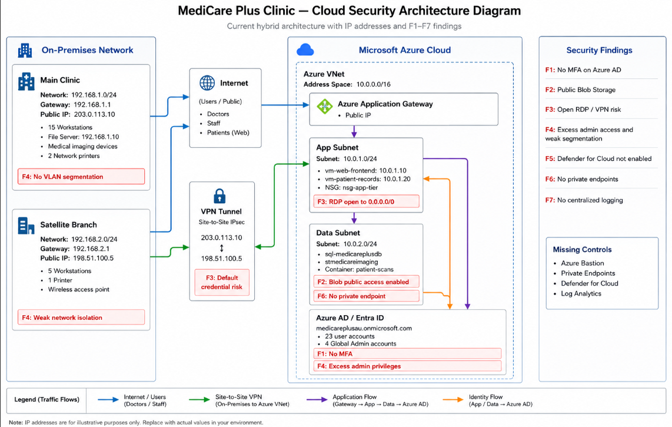

7 References
ACSC (Australian Cyber Security Centre) 2024, Annual Cyber Threat Report 2023–2024, Australian Signals Directorate, Canberra.
ACSC 2024, Australian Government Information Security Manual, Australian Signals Directorate, Canberra. Retrieved from https://www.cyber.gov.au/business-government/asds-cyber-security-frameworks/ism
Microsoft 2024, Azure Security Benchmark v3, Microsoft Learn.
Microsoft 2024, Microsoft Defender for Cloud documentation, Microsoft Learn.
MITRE 2024, ATT&CK for Enterprise: Cloud Matrix, MITRE Corporation.
NIST (National Institute of Standards and Technology) 2012, Guide for Conducting Risk Assessments, Special Publication 800-30 Rev. 1, US Department of Commerce, Gaithersburg. Retrieved from https://csrc.nist.gov/pubs/sp/800/30/r1/final
NIST 2020, Security and Privacy Controls for Information Systems and Organisations, Special Publication 800-53 Rev. 5, US Department of Commerce, Gaithersburg.
NSA (National Security Agency) 2024, Cybersecurity Advisories and Guidance. Retrieved from https://www.nsa.gov/Press-Room/Cybersecurity-Advisories-Guidance/
OAIC (Office of the Australian Information Commissioner) 2024, Notifiable Data Breaches Report: July to December 2024, OAIC, Canberra.
Privacy Act 1988 (Cth).
My Health Records Act 2012 (Cth).

